You can check your Solution here: <https://judge.softuni.bg/Contests#!/List/ByCategory/102/Data-Structures-Exercises>

# Java Tutorial

## Create our Project

### In this case we create new Class “ArrayList”

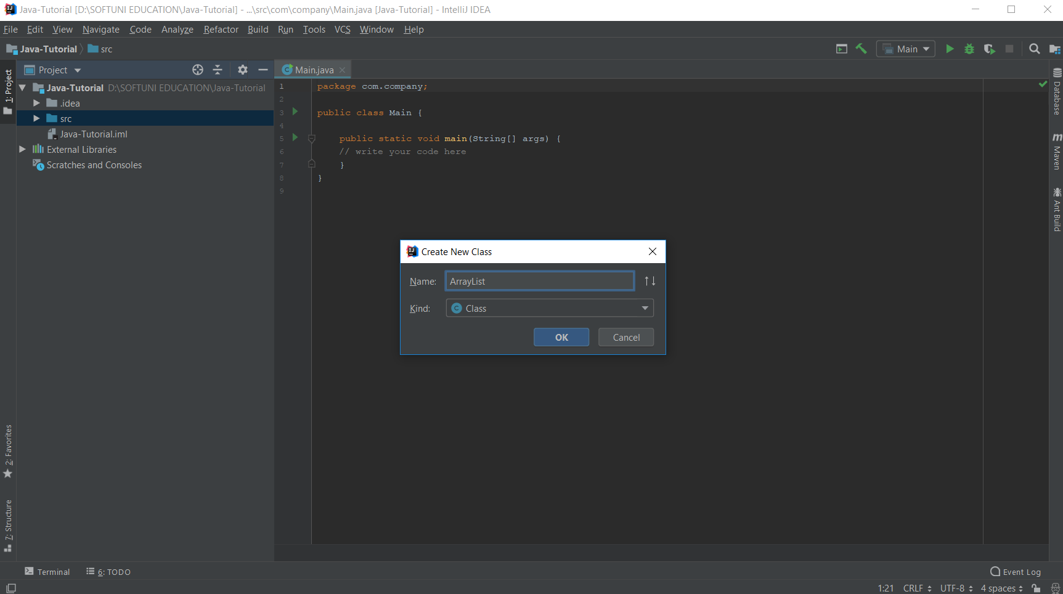Then, we write our class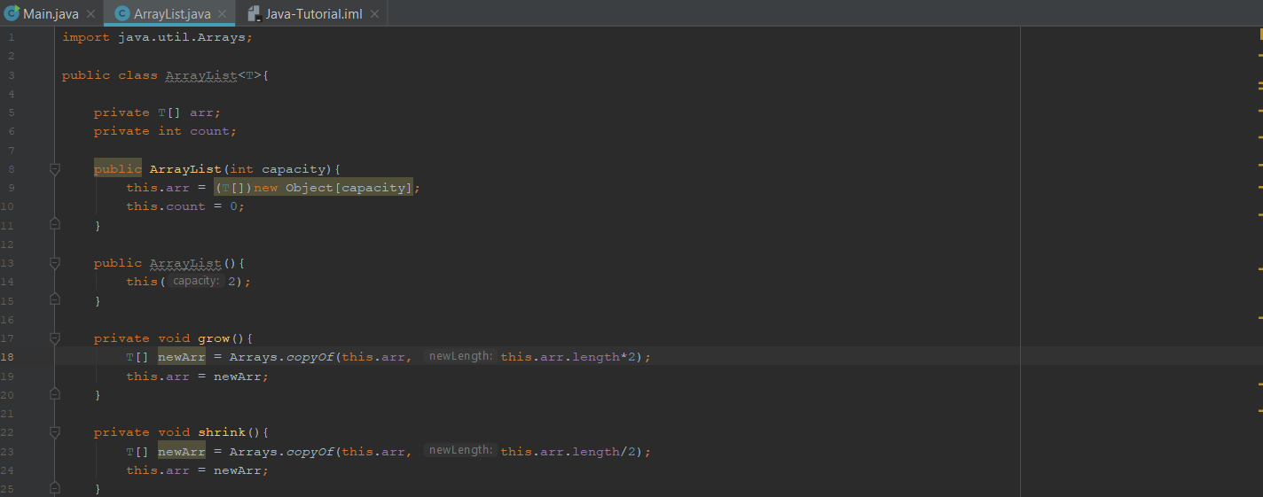

## Upload our Project in “Judge”

### Delete all packages from the code

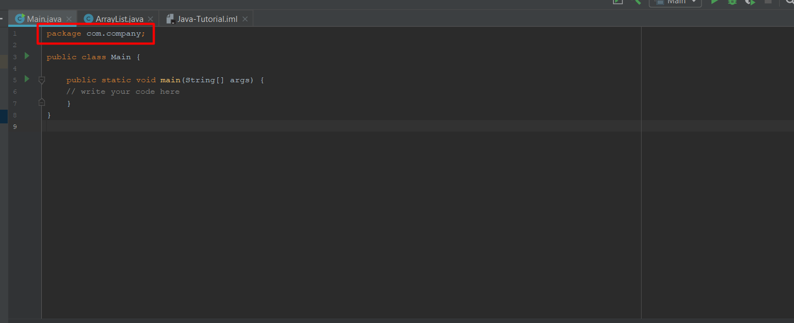

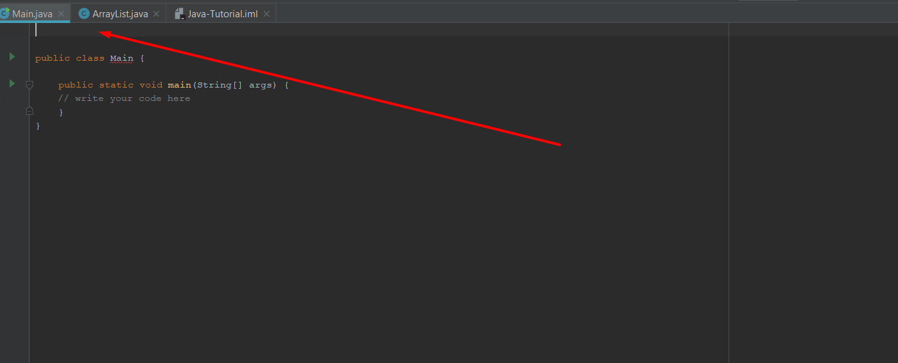

### Then we are almost ready, go to your project solution

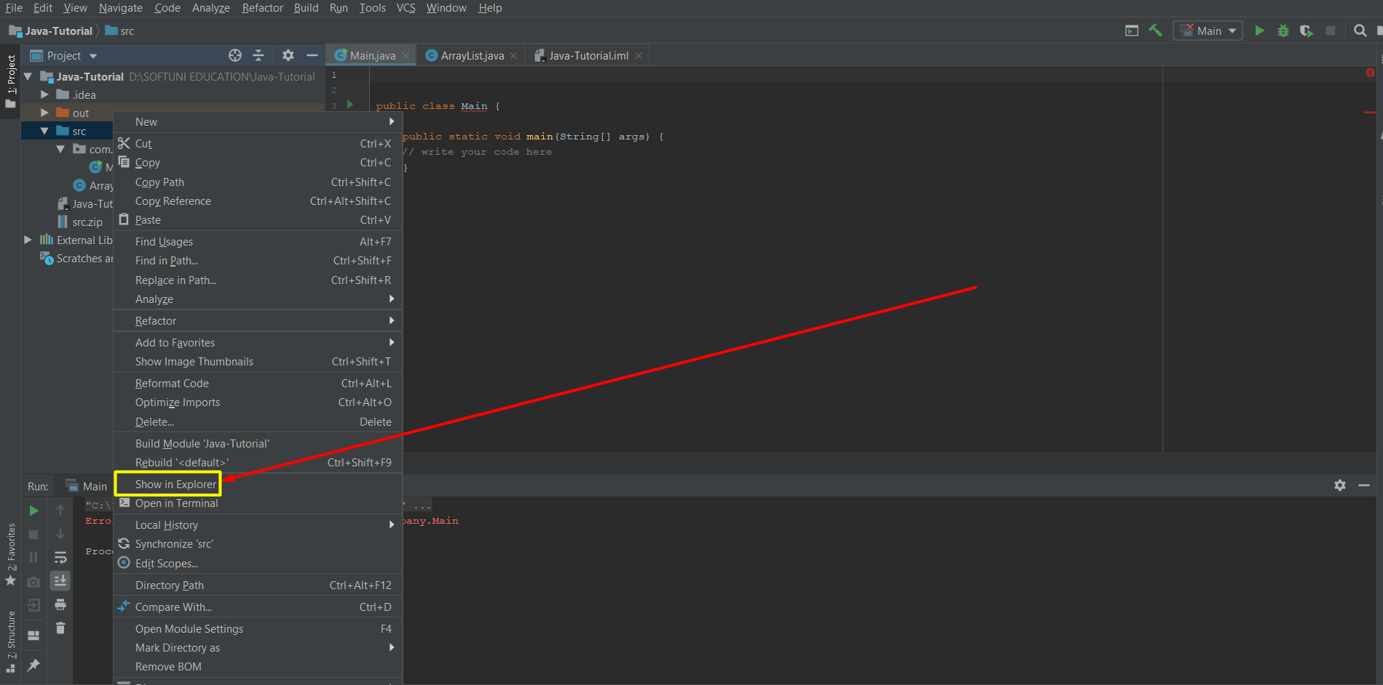

### Select ONLY the SRC folder, then compressed it to ZIP

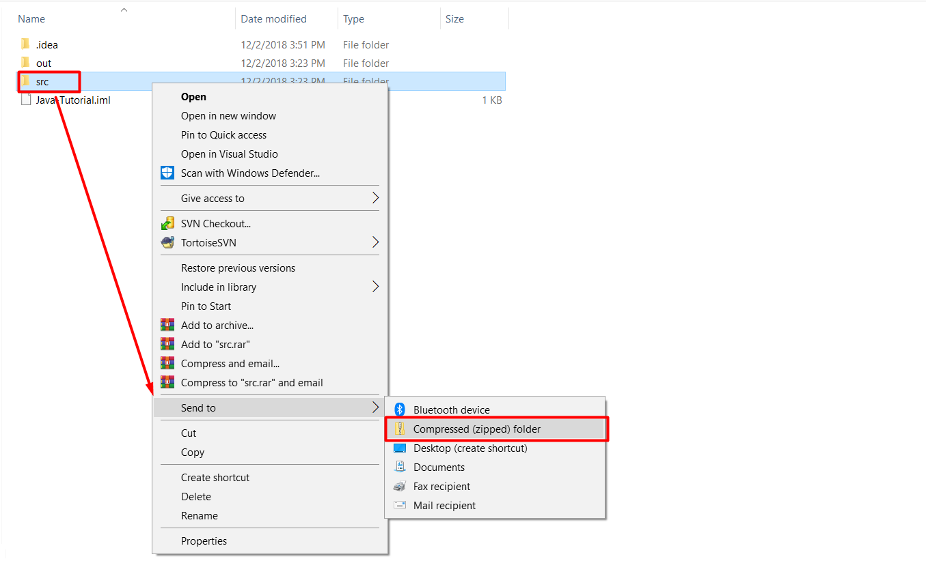

**Finally, we can submit our project(ZIP) in "Judge"**